# Website Plannig Document

# Site name

Willka Rafting Adventures

# Purpose

To promote rafting tourism in Huancavelica by providing information about the rivers, available tours, booking options, safety tips, and complementary outdoor experiences (like hiking, camping, and local gastronomy).

## Goals

* **Increase Local & Global Visibility:** Establish a strong online presence to promote Huancavelica as an emerging rafting destination and attract adventure-seeking tourists from Peru and abroad.
* **Showcase Unique River Adventures:** Highlight the natural beauty and excitement of rafting in rivers like the Mantaro and Pampas through high-impact images, videos, and client testimonials.
* **Provide Clear Information:** Deliver organized and accessible content about rafting routes, pricing, safety measures, schedules, and available packages.
* **Build a Passionate Adventure Community:** Encourage connection between guides, local communities, and visitors using social media, reviews, and shared travel stories.
* **Boost Bookings:** Convert web visitors into paying customers through special offers, seasonal discounts, group packages, and loyalty benefits.

# Target audience

**Demographics:**Adventure-seekers, outdoor lovers, local and international eco-tourists, youth groups, and family travelers.

**Psychographics:**Individuals and groups looking for adrenaline, nature connection, unique off-the-beaten-path experiences, and eco-cultural immersion.

**User Personas:**

* Sofia, 28, an adventurous traveler from Lima visiting the Andes.
* Hans, 34, a European backpacker exploring Peru’s less-known natural wonders.
* Juan & Rosa, a local couple seeking a weekend outdoor activity.
* School group, students on an educational nature trip with teachers.

# Scenarios

* What rafting difficulty levels are available (beginner to advanced)?
* What does the experience include (duration, equipment, guide)?
* Are there real customer reviews and photos?
* Are there family-friendly options and age restrictions?
* What safety protocols and equipment are included?
* Can I book a private guide or group package?
* What nearby activities exist for those who don’t want to raft?
* Are there photos and videos that show what it’s like?
* Can I customize my trip (e.g., camping, bilingual guide)?
* Where can I book a rafting tour near Huancavelica?
* Is rafting safe for beginners?
* What other activities can I do around the rafting area?

# A site map

# Branding

## Logo



# The style guide

## Color Schema

<https://coolors.co/005f73-94d2bd-ee9b00>

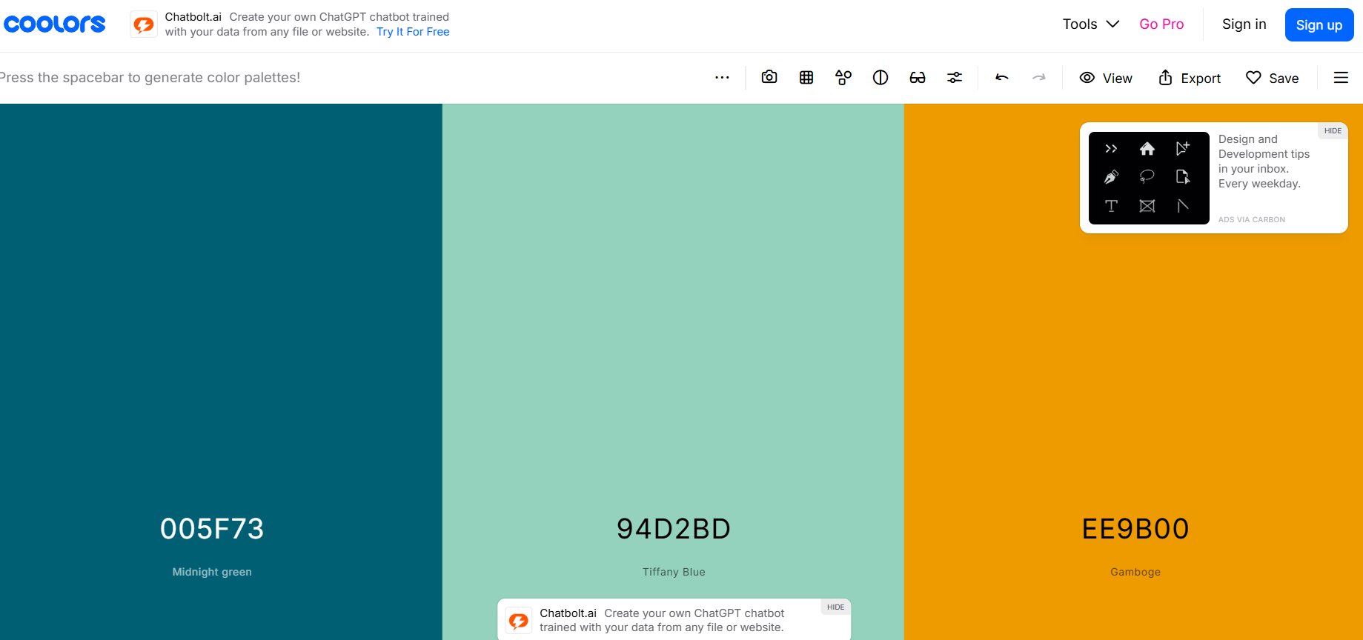

## Typography

Using <https://fonts.google.com>

Headings: **Montserrat**

Body Text: Roboto